.Trần Anh

20215179

Lab02

5.Create AimsProject

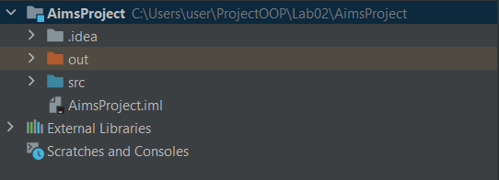

6. Create the DigitalVideoDisc class and its attributes

And 7. Create accessors and mutators for the class DigitalVideoDisc

Anh 8. Create Constructor method

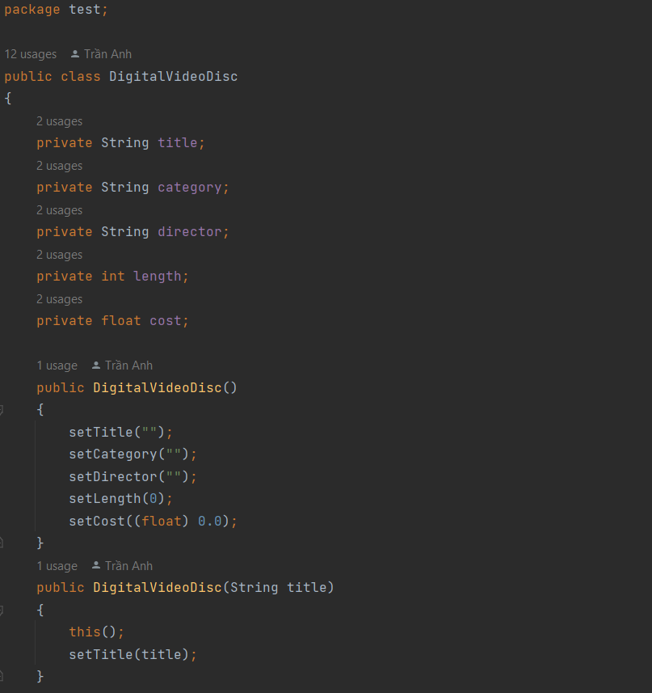

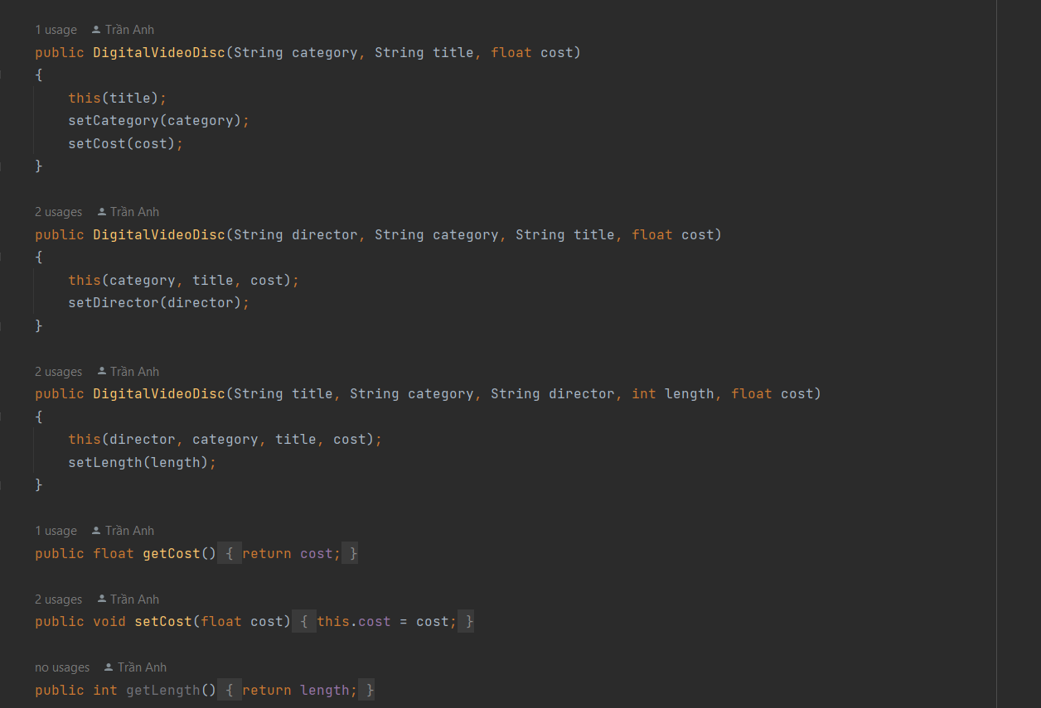

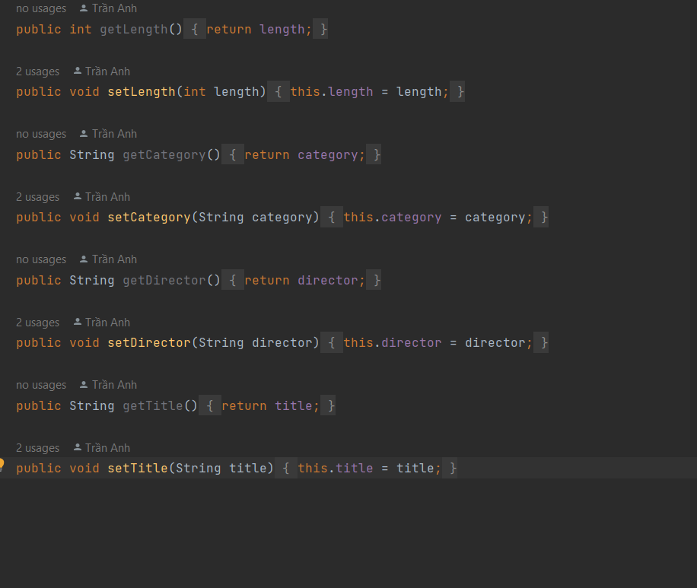

9. Create the Cart class to work with DigitalVideoDisc

And 10.Create Carts of DigitalVideoDiscs

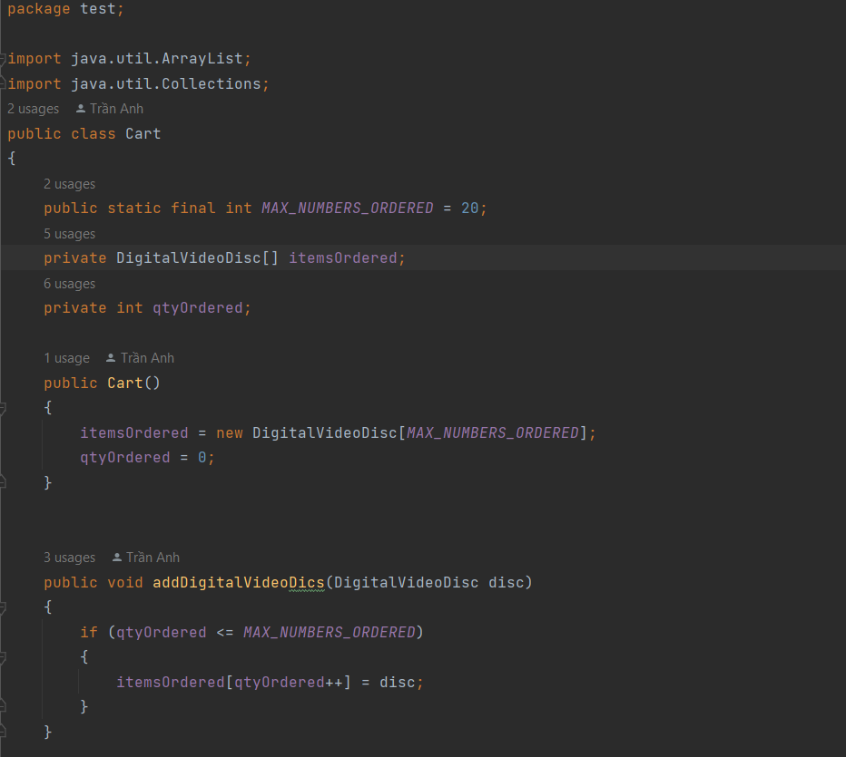

11.Removing items from the cart

**Runtest:**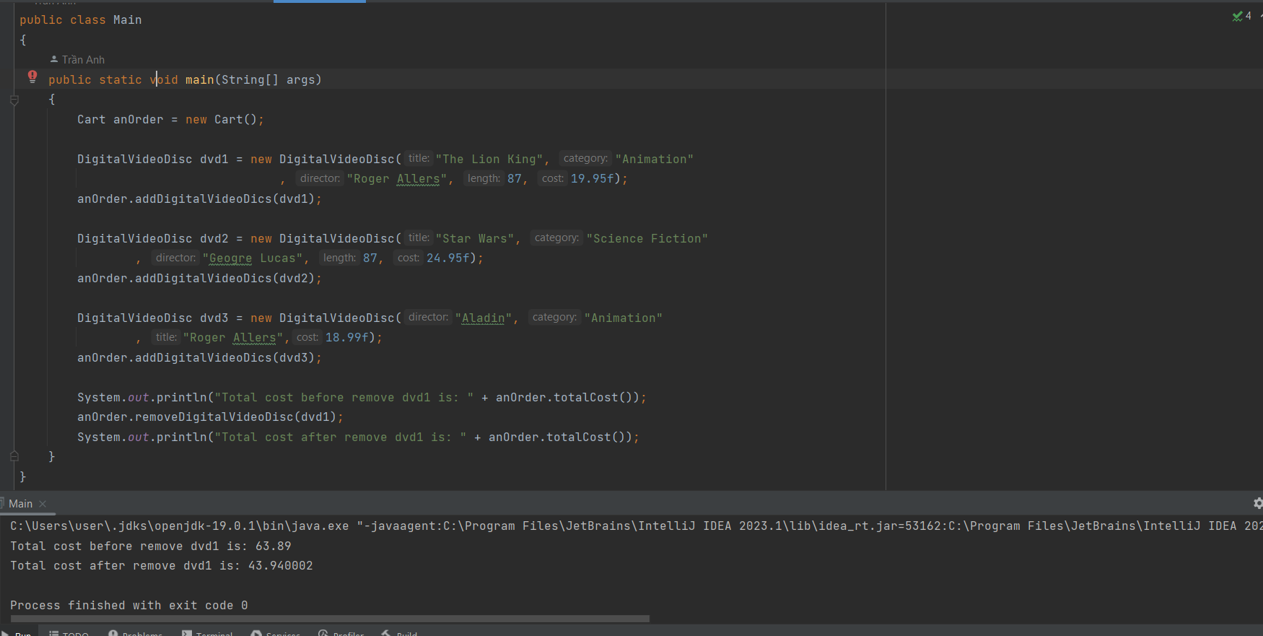

12. References

James Rumbaugh, Ivar Jacobson, and Grady Booch (2004). Unified Modeling Language Reference Manual,

The (2nd Edition). Pearson Higher Education.